**Insight Squad**

**Hospital Data Analysis**

**Optimal Month for Admissions and Revenue Calculation**

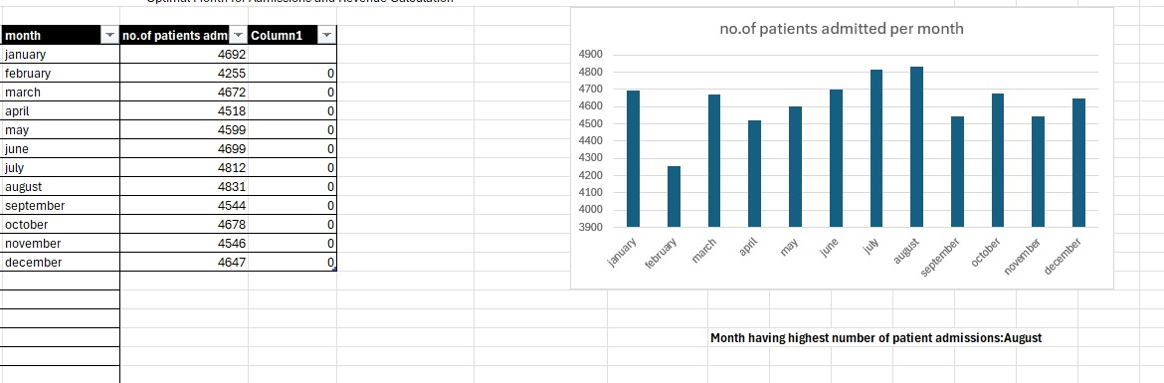

**Most Expensive Medical Condition and Hypothesis on Costs**

